VISTAAR GURUKUL
Vistaar Gurukul - Project Overview

- Introduction

Vistaar Gurukul is the mobile learning app of Vistaar Financial Services Pvt Ltd.
It enables the employees to learn about products, policies and also enhance their soft skills.
It offers bite-sized modules, which can be the time saving and fun way of learning.

- Target Audience
Vistaar Employees and CRO.

- Features and Functionality
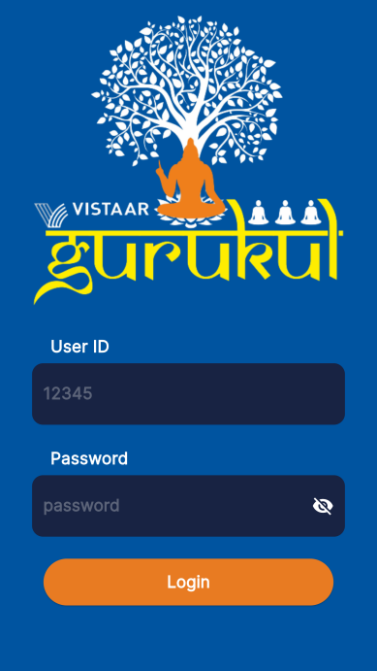
1.

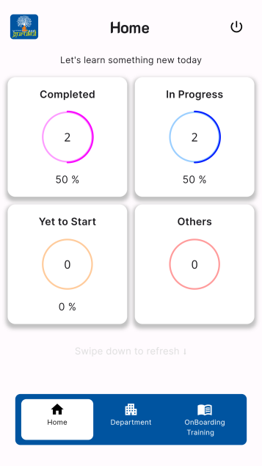
Login Screen: Allows User to login using there employee ID and password

2.

Dashboard: Dashboard consist of user progress. It consist of 4 sections namely: Completed, InProgress, Yet to Start and Others

Completed: This section consist of all the training and test which has been completed by the user. The user can revisit the training if they want to.

InProgress: This section consist of all the training and test which are in progress by the user. The user have to revisit the training and complete it.

Yet to start: This section consist of all the training and test which new for the user.

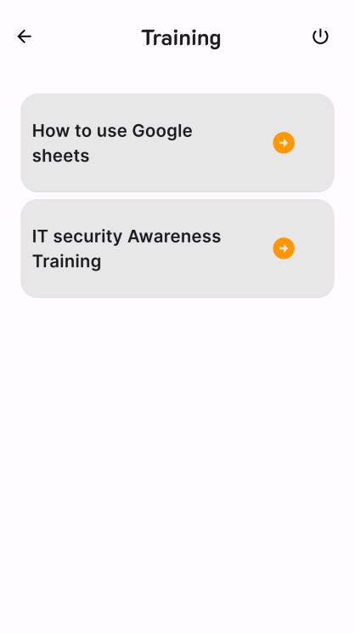

Training screen: This screen appears whenever the user visit or revisit any training.

It is a list of all the training available to the user.

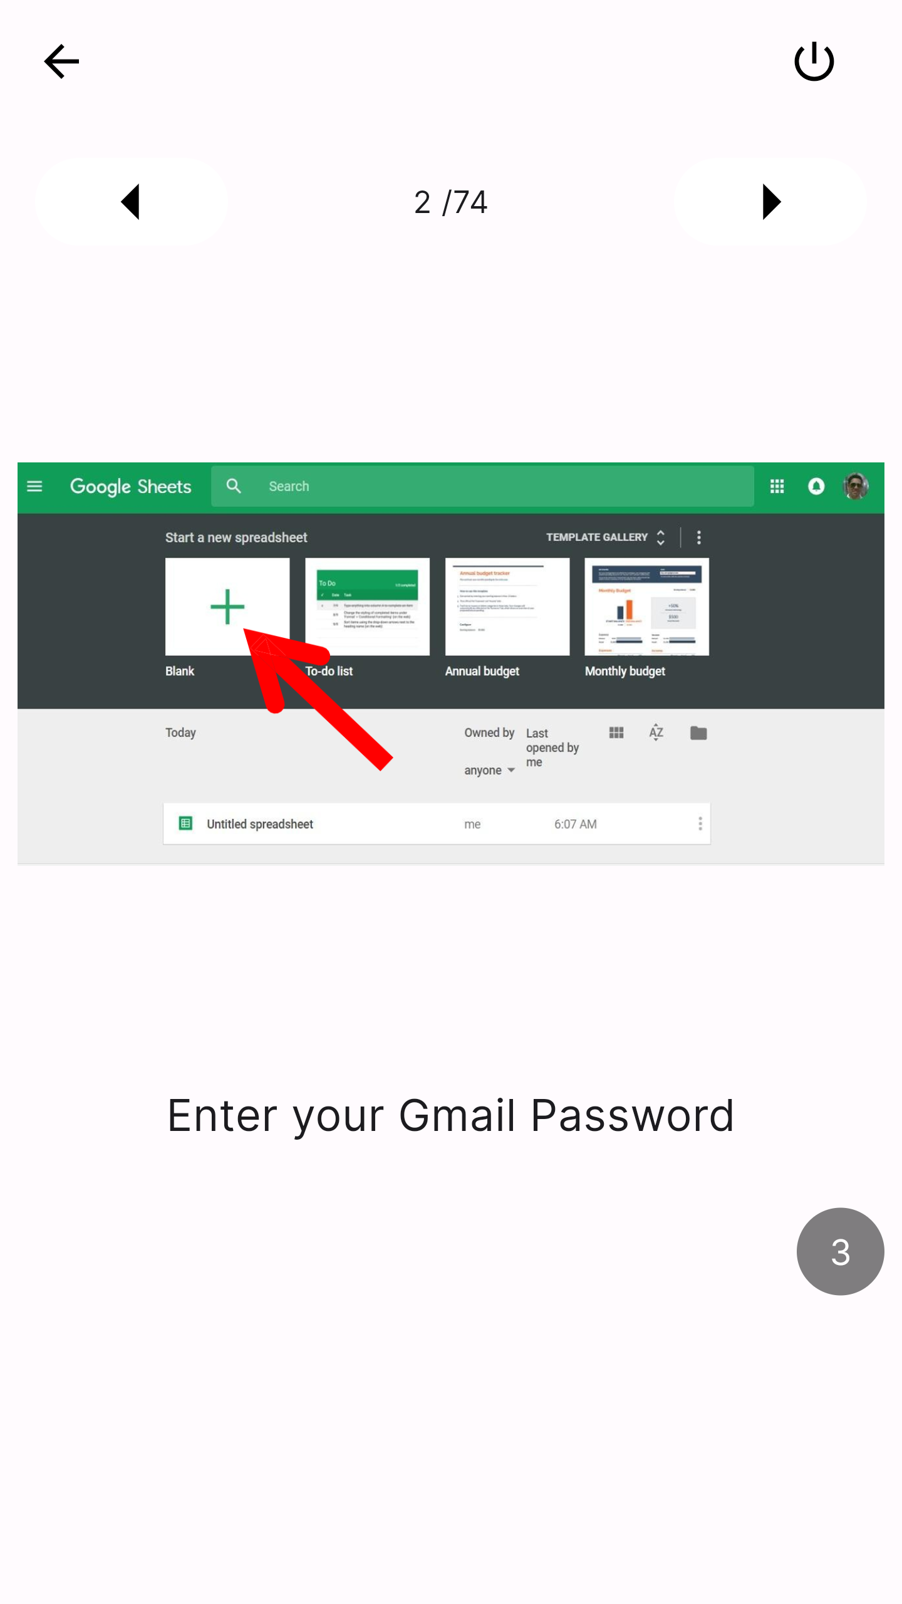

Content screen: This screen appears whenever the user open any training or test from the list of training in the the training screen.

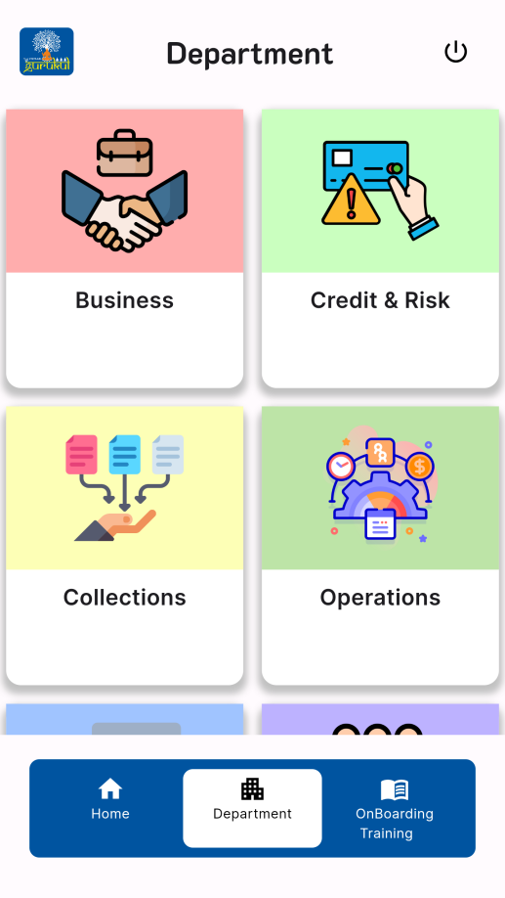
- A5.

Department Tab: Gives access for user to expand knowledge through departments.

